**CME Science Conference Airport transfers**

**Imaging in Costa Rica * February 10 – 13 , 2025**

|  |  |
| --- | --- |
| Arrival transfer from Daniel Oduber International Airport (LIR) in Liberia to JW Marriott Guanacaste at Hacienda Pinilla |  |
| **Prices per service or person** | **Price US$** |
| Service minimum 01 - maximum 04 participants private unescorted - per service | 188.00 |
| One bottle of water per person | courtesy |
| Caturgua assistance for meet & greet inside the airport per person | Included |
| **Prices per service (up to 3 guests per SUV)** | **Price US$** |
| Service in SUV like a Ford Expedition vehicle (includes 30 minutes maximum waiting time at the airport) | 328.00 |
| One bottle of water, one cold towel and porter tips at the airport per person included |  |
| Service in Mercedes Benz GLE Coupe or similar SUV vehicle (includes 30 minutes maximum waiting time at the airport) | 471.00 |
| One bottle of water, one cold towel and porter tips at the airport per person included |  |
| **Remarks** |  |
| 1- Luggage will be taken on board the vehicle. |  |
| 2- Transfer duration from Guanacaste Airport to JW Marriott Guanacaste is one hour and 30 minutes |  |

**Additional services**

* Drinks on a cooler on board

One bottle of water per person US$ 2.70

One local beer per person US$ 3.80

One soft drink per person US$ 2.70

One Pellegrino sparkling water bottle per person US$ 3.20

* Snacks (cost per unit)

US products like Doritos, Fritos, Lay's, Granola bars, chocolate bars,

cookies US$ 3.20

Costa Rican products similar to above as potato chips, plantain chips,

cassava chips, fajitas, nachos, cookies, dehydrated tropical fruit snack US$ 2.60

*** You can choose the quantity of snacks per person

|  |  |
| --- | --- |
| Departure transfer from JW Marriott Guanacaste at Hacienda Pinilla to Daniel Oduber International Airport (LIR) in Liberia |  |
| Service minimum 01 - maximum 04 participants private unescorted - per service | 188.00 |
| One bottle of water per person | courtesy |
| Caturgua assistance for meet & greet inside the airport per person | Included |
| **Prices per service (up to 3 guests per SUV)** | **Price US$** |
| Service in SUV like a Ford Expedition vehicle | 328.00 |
| One bottle of water and porter tips at the airport per person included |  |
| Service in Mercedes Benz GLE Coupe or similar SUV vehicle | 471.00 |
| One bottle of water and porter tips at the airport per person included |  |
| **Remarks** |  |
| 1- Luggage will be taken on board the vehicle. |  |
| 2- Transfer duration from JW Marriott Guanacaste to LIR airport is one  hour and 30 minutes |  |

**Arrival to Daniel Oduber International Airport (LIR) in Liberia** (*aka* Guanacaste Airport)

**Caturgua assistance for meet & greet inside the airport**

After clearing customs, you will leave the secured area inside the airport building and walk to the arrivals hall, where a staff from CATURGUA (Guanacaste Tourism Chamber) will hold a sign with passengers’ names and will ask for the name of each guest. Porters can be aside to assist with luggage (optional).

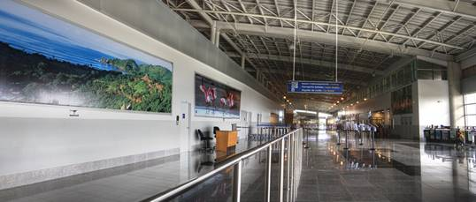

**View from customs exit doors**

**Arrivals hall**

**customs exit doors**

**Arrivals hall**

Guests must turn right twice, passing by the brick wall where restrooms are located and use the side glass doors to the parking lot. Please do not exit through the front doors that lead to the sidewalk. Immediately after the parking lot exit, a Costa Rica DMC meet & greet staff will be holding a sign with passengers’ names and a red balloon. At this point, guests will be directed to their corresponding transportation vehicle.

Once in the vehicles, participants’ name will be checked out and baggage will be placed on the luggage compartment for coaches or inside the vans or mini coaches.

**Airport porterage** Porters are usually located in the arrivals hall within the airport building for travelers to use at disposition. When coordinated in advance along with CATURGUA meet & greet, will assist inside; otherwise, porters will help outside the airport building with baggage handling, and will wait next to Costa Rica DMC meet & greet staff, after crossing the glass doors into the parking lot.

As for departures, we can use porters’ service from the curbside to the beginning of the airline counter line which is a very short distance, or just let guests know that they are optional.

**Departure transfer from Daniel Oduber International Airport (LIR) in Liberia**

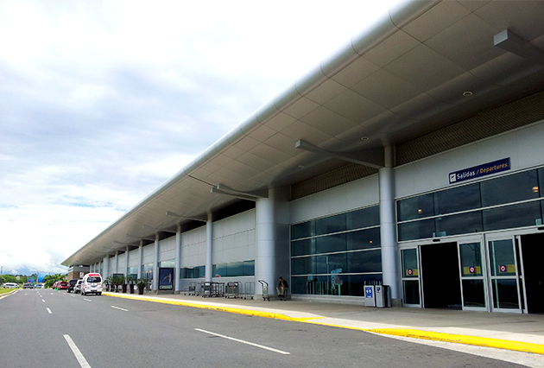Check in at Guanacaste Airport must be at least 2 hours prior to the scheduled departure time for international flights.

We suggest handing out departure notices with departure instructions to the airport at least two days ahead of departure day.

All passengers must identify their suitcases before boarding our vehicles at the hotel, in order to load them into the vehicles.

Luggage will travel with participants in all cases. Guests will be dropped off at the sidewalk in front of the departures terminal, so they can walk directly to the airline counter desks.